“A spatial framework for multifunctional agricultural landscape transformation”
“Implications for systematic conservation and bioeconomic planning”
“A Spatial Framework for Multifunctional Agricultural Landscape Transformation and Bioenergy-Integrated Watershed Planning”
“A Spatial Framework for Multifunctional Agricultural Landscape Transformation and Watershed Planning Archetypes”

ABSRACT

Introduction
Agricultural landscapes across the U.S. Corn Belt face increasing pressure to balance commodity production and renewable energy with soil health, water quality, wildlife habitat, and greenhouse gas (GHG) objectives (Prokopy et al., 2020). In Iowa, multiple public and private entities pursue solutions through separate programs and planning processes, creating a need for approaches that coordinate environmental and economic goals (Dangol et al., 2025; Kreig et al., 2019). Cropland comprises 85.7% of Iowa (NASS, 2024) and agricultural production contributes to nitrogen (N) loss through leaching, subsurface drainage, runoff, and atmospheric emissions resulting in nutrient pollution, biodiversity loss, impaired recreational waters (Baron et al., 2012; Galloway et al., 2004; Jones et al., 2018; Porter et al., 2013). Nitrous oxide (N₂O) has nearly 300 times the warming potential of CO₂ (Myhre et al., 2013), contributing to Iowa’s transition from a historical prairie GHG sink to a major agricultural GHG source (Bossio et al., 2020; ICCAC, 2007; Paustian et al., 2019; Verge et al., 2007).
Addressing these interacting challenges requires coordination among conservation objectives that are often conceptualized and pursued independently. The Iowa Nutrient Reduction Strategy (INRS; IDALS 2025) targets N and phosphorus losses from cropland, the Iowa Wildlife Action Plan (IWAP; IDNR 2015) identifies opportunities to increase permanent cover and grassland habitat, and the Iowa Climate Change Advisory Council Final Report (ICCAC 2008) identifies biomass systems and anaerobic digestion (AD) among strategies for reducing agriculture and energy sector emissions. These complementary objectives create opportunities for coordinated action, yet identifying where they can be pursued simultaneously requires spatial data and tools capable of translating broad conservation goals into field- and watershed-scale priorities. Nevertheless, conservation planning has often focused on individual practices or objectives rather than evaluating how complementary practices can be spatially combined and their outcomes aggregated at various scales of planning and biogeophysical systems (Cash and Moser 2000; Tomer et al., 2015). Likewise, limited planning capacity, spatial data, and analytical tools have historically constrained efforts to identify and coordinate opportunities at field and watershed scales (Tyndall, 2020). As a result, locations where multiple objectives could be addressed simultaneously may not be readily apparent through individual programmatic approaches (Wardropper et al., 2015; Wardropper et al., 2023).
Advances in geospatial data and spatial decision-support systems (SDSS) provide new opportunities to translate these overlapping objectives into spatially explicit conservation strategies (Bravard et al., 2024; Liu et al., 2026). Systematic conservation planning (SCP) provides a framework for coordinating conservation objectives across organizations and spatial scales (Bode et al., 2011; Chan et al., 2006; Turner et al., 2007), while SDSS tools can identify field-to-basin scale locations where combinations of practices address multiple objectives (Bodrud-Doza et al., 2023; Liu et al., 2026). Coordination is particularly important for voluntary conservation, where limited funding, program oversubscription, landowner participation, and transaction costs constrain implementation (Coppess, 2023; Kling et al., 2025; McCann and Clausen, 2016; Moriasi et al., 2020).
An additional challenge is that field-scale targeting can produce heterogeneous combinations of conservation practices across agricultural watersheds (Bodrud-Doza et al., 2026). Precision conservation provides a framework for addressing this heterogeneity by using spatially explicit information to target conservation interventions where environmental vulnerability, treatment opportunity, and implementation conditions overlap. Spatial decision-support systems can extend this approach beyond individual practice placement by evaluating how field-scale interventions interact across larger planning units and by making environmental and economic tradeoffs visible to conservation planners and stakeholders (Tomer et al., 2013; Delgado et al., 2018; Bodrud-Doza et al., 2023). Archetype analysis provides a complementary approach for interpreting this heterogeneity by identifying recurring combinations of landscape characteristics, interventions, and outcomes that represent distinct planning contexts (Eisenack et al. 2021; Oberlack et al., 2019). Applied at the watershed scale, planning archetypes can characterize recurring landscape configurations and identify scales of landscape transformation outcomes to inform distinct planning contexts without reducing environmental, biomass, and economic objectives to a single priority score.
Here, we demonstrate a spatial decision-support framework that integrates precision conservation with biomass production to evaluate multifunctional agricultural landscape transformation from fields to watersheds. The framework combines the Agricultural Conservation Planning Framework (ACPF; Porter et al., 2024), Financial and Nutrient Reduction Tool (FiNRT; Bravard et al., 2022), and companion GIS tools to identify where environmental vulnerability, conservation opportunity, and agricultural context jointly support land-use change. Rather than treating marginal land as a fixed category or framing landscape design primarily as a mathematical optimization problem (e.g., Akdemir et al., 2025; Gelfand et al., 2013), this framework offers a complementary planning approach that begins with established conservation objectives, translates them into coordinated field-scale interventions, and evaluates how those interventions can be assembled into alternative multifunctional watershed configurations.
We apply the framework within a biomass supplyshed surrounding an active AD facility in east-central Iowa. This setting provides a defined market context in which emerging demand for agricultural biomass can be evaluated alongside existing conservation priorities. The case study integrates perennial and winter biomass systems, including prairie plantings and winter biomass (cereal rye, Secale cereale), with vegetative and structural conservation practices identified through state conservation objectives. The framework evaluates these interventions at field and HUC12 scales and subsequently characterizes recurring watershed planning configurations. In this application, the HUC12 functions as the primary planning and aggregation unit, whereas the supplyshed defines the broader bioenergy market context. Rather than generating a single composite priority score, the framework retains environmental, biomass, treatment, and economic dimensions separately so that conservation planners and other stakeholders can evaluate tradeoffs according to their own objectives. In this context, systematic conservation planning (SCP) moves beyond an optimization exercise, functioning instead as a pragmatic tool designed to navigate complex decision-making by local resource planners.
Specifically, the study aims to: (1) identify spatially targeted opportunities for integrating perennial and winter biomass systems with existing conservation-practice priorities within an AD supplyshed; (2) quantify potential water-quality, erosion, GHG, habitat, and biomass outcomes, along with treatment extent and implementation costs, at field and HUC12 watershed scales; and (3) identify recurring watershed planning archetypes based on combinations of landscape transformation, conservation-practice composition, environmental outcomes, biomass production, and implementation requirements, and evaluate the agricultural and economic context associated with those archetypes.

Materials and Methods

Study Area
We used a 32-km radial “supplyshed” around an active anaerobic digestion (AD) facility in east-central Iowa to evaluate the strategic integration of conservation practices and biomass production (Figure 1). The supplyshed defined the spatial extent of the bioenergy opportunity, whereas HUC12 watersheds were used as the primary landscape planning and aggregation units. The operational facility provides a defined biomass-market boundary within which potential land-use changes can be evaluated, linking spatial conservation planning to an emerging agricultural biomass supply chain. The study AD facility generates energy to support its commercial farm operation and provides a real-world context for evaluating how additional biomass resources could be spatially distributed across the surrounding agricultural landscape. The 32-km supplyshed encompasses 313,962 ha, of which 73.0% is row crop agriculture (e.g., corn-soybean), 7.6% pasture, and 0.3% urban development (NASS 2024; Figure 1). The region also contains 16,800 ha of forested land (5% of supplyshed; NASS 2024), primarily concentrated along riparian corridors and at least 2,235 ha of permanent conservation easements (0.7%; NCED; https://www.conservationeasement.us/about/, and Figure 1). For a full summary of land cover see Table 1).
Major land resource areas (MLRAs) were used as a planning unit following INRS scenarios because agricultural conditions differ and therefore conservation needs and practice recommendations also vary (Christianson et al., 2018; INRS 2025). Four MLRAs intersect the case study region, including Illinois and Iowa Deep Loess and Drift, West-Central part (108c), Eastern Iowa and Minnesota Till Prairies (104), Northern Mississippi Valley Loess Hills (105), and Central Mississippi Valley Wooded Slopes, Northern Pat (115c) (Prior 1991) (Table 1). Extensive tile drainage networks are highly likely (based on soil and slope characteristics) contributing to nitrate export and loading in stream systems (Schilling and Libra 2000; Schilling and Spooner 2006; INRS 2025). Additional loading results from inorganic fertilizer and livestock manure applied to row crops (INRS 2025), however, this planning framework currently does not differentiate between inorganic and organic N sources.

Conservation and biomass planning framework
A multi-objective, spatially explicit framework is demonstrated using ArcGIS Pro 3.3.1 and geospatial tools, including the ACPF, FiNRT, and the Overland Flow Element (OFE) tool. These GIS tools were developed for conservation planning and follow Natural Resources Conservation Service (NRCS) conservation practice guidance that align with federal funding programs (Porter et al. 2025). While our use of this integrated suite of GIS tools is specific to a case study context, the datasets and tools are versatile and broadly transferable to other regions where comparable public spatial data are available (https://acpf4watersheds.org/toolbox). The flow of data between tools is summarized in Figure 2.
The ACPF consists of a core spatial dataset organized by HUC12 watershed boundaries to identify spatially explicit field-scale conservation opportunities on agricultural land (Porter et al., 2025). The core dataset includes 10-m gSSURGO, annual cropland data layers (CDL) from NASS, HUC12 watershed boundaries, and summary tables describing soil and land use for each field. Field boundaries are based on a common land unit (CLU). Because ACPF depends on accurate surface flow paths, hydroconditioned 2-meter digital elevation models (DEM) were prepared for all watersheds intersecting the supplyshed. In total, 48 HUC12 watersheds intersected the 32 km supplyshed and were included in the analysis (Figure 1). The framework begins with established state-level conservation priorities and translates them into spatially explicit planning scenarios that can be evaluated alongside biomass production objectives. The INRS provides primary science-based perspective for nutrient reduction in the state, while the IWAP provides a complementary statewide goal for increasing permanent vegetative cover. Rather than treating the maximum extent of any single conservation practice as a prescribed landscape configuration, we used four INRS single-practice scenarios as planning benchmarks relative specifically to nitrate-N reduction to establish the potential extent and spatial targeting of conservation practices relevant to the case study. These benchmarks included cereal rye cover crops, nutrient-retention wetlands, riparian buffers, and perennial energy crops.
Specifically, the MLRA-specific INRS scenarios utilized represented: (1) “Plant a rye cover crop on all no‐till acres”; (2) “Installing wetlands to treat 45% of the agricultural land”; (3) “Installing buffers on all applicable acres”; and (4) “Perennial crops (energy crops) to equal pasture/hay acreage in 1987”(INRS Section 2 Scenarios CCa, W, BF, and EC respectively, pp. 33-39). These scenarios were used as benchmarks for defining the potential extent of individual practices; the resulting multifunctional landscape was subsequently developed by identifying where these practices could jointly address environmental vulnerability, biomass production objectives, and landscape constraints. In the case of Scenario BF, saturated buffers were assumed to be installed in locations where ACPF sited them.
Dedicated prairie biomass production sites were co-located with vegetative conservation practices identified through ACPF outputs; vegetative practices include nutrient removal wetland buffer areas, prairie strips, and herbaceous riparian buffers along with complementary saturated buffers. When additional vegetation generated from these site-specific ACPF practices is insufficient to meet INRS land-area targets, additional whole fields were allocated to prairie and cereal rye production based on soil loss vulnerability and proximity to existing wildlife habitat complexes. Environmental outcomes and costs were reported at both field- and HUC12 watershed scales.
The soil loss vulnerability index (SVI) output from ACPF was used to prioritize cropped fields with moderate-to-high vulnerability to surface runoff or leaching. The SVI identifies fields susceptible to soil loss from surface flows and steep slopes (Lohani et al., 2020; Porter et al., 2025). From fields meeting these criteria, a randomization process was used to select fields receiving prairie or cereal rye treatment. Random selection among otherwise eligible fields was used to avoid implying that the model could identify a unique optimal set of fields when multiple spatial configurations could satisfy the same planning target.
The Scenario CCa does not have a built-in workflow in ACPF for siting cereal rye fields. Therefore, ACPF datasets were combined to manually identify fields based on land use between 2019 and 2024, and field boundaries. Cereal rye was restricted to corn-corn (CC) or corn-soybean (CS) rotation fields identified as no-till candidates since the INRS scenario specifies rye cover crops on no-till fields. No-till was therefore used as a siting criterion, rather than as a modeled treatment effect. Environmental outcomes attributed to the scenario reflect the modeled effect of cereal rye and do not include additional benefits attributable to no-till management. Because field specific information on soil management is not available, no-till fields were randomly assigned according to the proportion of no-till acreage reported for MLRA 104, 105, 108c, and 115c (INRS 2025) (Table 2). From the queried fields, outputs from the SVI were stacked, and fields that had a moderate to high SVI class were selected to receive a cereal rye treatment.
In Scenario W, nutrient-retention wetlands (NRW) identified through ACPF outputs were used to determine wetland installation sites (Porter et al. 2025). Vegetative buffer areas were assumed to equal 3.5% of each wetland drainage area (Bravard et al., 2022) and were assumed to be harvestable for prairie biomass. Wetlands with majority of the buffer spanning multiple fields were excluded to maintain consistent field-level attribution and implementation assumptions.
Scenario BF was modified to prioritize locations also suitable for saturated buffers, thereby addressing both runoff and subsurface nitrate transport pathways. The denitrifying practice tool within ACPF was used to identify saturated buffer locations (Tomer et al., 2020). Buffers centered on cropland were retained, whereas buffers primarily associated with pastureland were excluded. A standardized buffer width of 30.5 meters was used as needed to accommodate harvest machinery while minimizing streambank disturbance and supporting area-sensitive wildlife species (Brittingham & DeCecco, 2025).
Scenario EC focused on increasing perennial cover through native tall grass prairie. This scenario also aligns with the IWAP recommendations to permanently protect 4% of Iowa’s land area. Cropped fields nearest (Euclidean) to existing NCED-reported permanent easements were selected to support a connected habitat matrix (NCED 2024). Remaining perennial biomass targets were met through a combination of prairie strips and whole field conversion from annual cropping systems to prairie.
The ACPF Contour Buffer Strip (CBS) tool was customized to identify prairie strip locations using an 18.3-meter buffer width (Respess and Duncan 2021). Buffer widths were selected based on commercial windrower dimensions and NRCS wildlife recommendations (NRCS, 2014). CBS outputs were further filtered to ensure strips occupied at least 10% of the field to maximize sediment and nitrate reduction, and wildlife habitat benefits (Schulte et al., 2017). Remaining perennial energy cropping area needed to achieve scenario four was allocated to fields classified with moderate, moderately high, or high SVI values.

Ecosystem service and biomass outcomes
The spatial framework presented in this paper reports ecosystem service outcomes on a per year basis and reports the capacity of the landscape to generate ecosystem services annually. To estimate sediment loads, the OFE tool downscaled output from Daily Erosion Project (DEP; DEP 2025) and produced field and sub-field scale soil loss estimation data based on land use, slope, soil, and tillage characteristics. Daily Erosion Project data were used (DEP; https://www.dailyerosion.org/) to quantify soil displacement along hillslopes and estimate average runoff and soil displacement at the field scale. The model uses the Water Erosion Prediction Project (WEPP) and an event-based modeling approach to evaluate precipitation, hillslope, and soil detachment characteristics. The OFE Tool inputs include ACPF core datasets, a hydroconditioned DEM, and a tillage raster generated from seasonal aerial imagery to estimate residue management. Sediment transport and delivery were estimated for each field using the OFE tool and reported as kg sediment ha⁻¹ (Luquin et al., 2024).
Using FiNRT, baseline nitrate loads for each field were estimated from cropping history between 2019 to 2024 and fertilizer rates were derived from maximum return to N (MRTN) guidance. FiNRT quantifies field-level nitrogen requirements based on 6-year land-use data and estimates the proportion of applied nitrogen likely to be lost through nitrate leaching (Bravard et al., 2022). The by-field sediment loads calculated from the OFE tool output and nitrate load calculated using FiNRT were used as the baseline loading potential. The contributing area to each vegetative practice was calculated, and the area-weighted estimates of nitrate and sediment reduction were reported for each field. The nitrate load reduction fraction for each practice was selected from the INRS (2025) and the sediment load reduction fractions were taken from the Management Option Simulation Model (MOSM) values (TetraTech 2019). Load reductions due to different configurations of vegetative conservation practice implementation were calculated within FiNRT. Once by-field load and load reduction estimates were determined, annual load data were aggregated and summarized at multiple planning scales, including field, HUC12, MLRA, and supplyshed.
Principles from landscape matrix management were used to estimate wildlife habitat outcomes in agricultural landscapes (Franklin and Lindenmayer, 2009). Whole-field prairie conversions were treated as core habitat patches containing interior habitat unaffected by edge conditions (Gilbert-Norton et al. 2010), riparian buffers as linear corridor elements (Fischer and Fischenich 2000), and prairie strips were treated as stepping-stone features that increase landscape permeability (Gilbert-Norton et al. 2010; Resasco 2019). Nutrient removal wetlands were excluded from the prairie habitat analysis because they are engineered primarily to treat agricultural runoff, although they do provide ancillary wildlife benefits (Lenhart et al. 2017; Nietch et al. 2024; Tomer et al. 2015). A weighted prairie density map was generated as a quick exploratory visualization of potential wildlife habitat concentration; however, it is not a measure of functional connectivity and is only an evaluation of where the proposed new prairie is concentrated on the landscape relative to existing permanent habitat locations reported in NCED. Each whole-field prairie conversion, prairie strip, and riparian buffers was weighted differently (3, 2, and 1, respectively) based on their assumed functions and values in providing nesting, forage, and corridors for prairie species. These analytical weights were used for a screening analysis, rather than empirically validated habitat values. Focal neighborhood radius of 300 m was used to represent local-scale habitat aggregation. Since we are broadly applying movement between patches across several prairie species, a conservative distance was selected reflecting the spatial scale at which adjacent prairie elements function collectively as usable habitat for multiple grassland bird species and smaller mammals in agricultural landscapes.
GHG emission outcomes associated with land-use change were estimated for each conservation practice. Ex ante GHG impacts were derived from published meta-modeling COMET-Farm simulations across soils, climate, and management conditions across MLRAs and aligned with USDA farm-scale GHG inventory methods. Following Swan et al. (2020), prairie cover was assumed to reduce emissions by 1.08 Mg CO₂ eq ha⁻¹ yr⁻¹ for CO₂ and 0.31 Mg CO₂ eq ha⁻¹ yr⁻¹ for N₂O, while cereal rye reduced emissions by 0.79 and 0.12 Mg CO₂ eq ha⁻¹ yr⁻¹ for CO₂ and N₂O, respectively.
In addition to environmental outcomes, biomass production was quantified as another ecosystem service. Because the analysis used high-resolution datasets to generate field-scale estimates, the treated area and corresponding biomass production for each practice could be calculated assuming uniform yields across treated acres. We used standard yield factors of 7.59 Mg ha⁻¹ yr⁻¹ for fertilized prairie (Giddens et al. 2017; Nichols et al. 2014) and fertilized cereal rye 4.0 Mg ha⁻¹ yr⁻¹ (Crespo et al. 2025; Feyereisen et al. 2013) assuming both systems are fertilized to achieve optimal results. There is a wide range of biomass yield values reported in the literature, depending on plant and harvest dates, growing degree days, and environmental factors, however, the one chosen for this study was frequently within the range of yields reported in field studies (Kantar et al. 2011; Malone et al. 2023). A limitation of this approach is that it does not account for likely subfield yield variability (Roni et al., 2023).

Implementation Costs
Cost estimates were used to characterize the implementation and agricultural context of the spatially targeted conservation-biomass systems rather than to identify a single economically optimal landscape configuration. FiNRT was used to estimate two components of cost for each intervention: direct implementation costs, including installation and management, and land-use opportunity costs associated with changing the use of agricultural land. Together, these measures provide a basis for evaluating the practical and economic context of alternative landscape configurations (Tyndall and Roesch 2014). Cost-effectiveness was calculated for each modeled biophysical outcome by dividing the annualized cost of a conservation-biomass practice by the corresponding annual environmental or biomass outcome (Tyndall et al., 2013). Thus, cost-effectiveness provides a means of comparing the resources required to generate individual outcomes rather than identifying an economically optimal combination of practices.
Direct implementation costs were estimated using comprehensive conservation practice enterprise budgets expressed in 2026 USD and discounted cash-flow methods over a 10-year period using a 6% real discount rate to represent the cost of capital. The direct costs are broken down into two different categories: 1. Structural and Vegetative (Struc + Veg), and 2. Vegetative (Veg). The Struc + Veg category includes direct costs associated with installation, operation and maintenance of the structural (i.e., control structures, basin creation) and establishment, management, fertilization, and harvest of the vegetative components (e.g., buffer) of the practice. The Veg category only includes costs for establishment, management, fertilization, and harvest of the vegetative practice. Site design in both categories is assumed to be completed by local technical assistance provider (e.g., NRCS) and the costs are left out of the budget. In the case of STB and RIB, the vegetative component incurs the same direct costs. We assumed that the impact of winter biomass on subsequent corn and soybean yields is negligible (e.g., Marcillo and Miguez 2017), and that there are no negative interactions between prairie practices and yields of adjacent crops (Schulte et al, 2017).
Watershed Planning Archetypes
Watershed planning archetypes were developed to classify HUC12 watersheds according to their combinations of landscape transformation, environmental outcomes, biomass production, and implementation costs. A clustering analysis was conducted in R 4.5.1. A principal component analysis (PCA) was used to characterize the dominant multivariate gradients and visualize relationships between variables. K-means clustering was subsequently to standardize original variables and used to classify HUC12s according to their combinations of planning characteristics. Clustering was treated as a classification procedure rather than a measure of watershed quality, priority, or performance. The k-means algorithm (MacQueen 29167) was used with the ecosystem service outcomes and direct costs (Table 4).
Metrics were first aggregated from field-level outputs to the HUC12 planning unit. Landscape-scale environmental and biomass outcomes and implementation extent were normalized by total HUC12 area to allow comparison among HUC12s of different size. Variables used for classification included the proportion of HUC12 area affected by planned intervention, proportions allocated to prairie patch, linear prairie, and cereal rye systems, area-normalized nitrate and sediment outcomes, and area-normalized direct implementation costs (Table 4). All variables were centered and scaled using the scale() function prior to analysis to remove scale effects and give each metric equal weight.
Watersheds were then grouped using k-means clustering based on the standardized PCA input variables. The number of clusters was selected through iterative evaluation of cluster separation, interpretability, and within-group variance. Resulting clusters were interpreted as watershed planning archetypes representing differing combinations of landscape transformation (i.e., extent of adoption), multifunctional environmental performance, biomass productivity, and implementation cost.
Cluster summaries were calculated using mean values of the original watershed-scale variables to facilitate interpretation of tradeoffs among watershed groups. Treatment-level performance???. To distinguish landscape-scale outcomes from outcomes associated with the amount of land treated, treatment-level metrics were calculated for each HUC12 as total modeled outcome divided by total treated area. Metrics included nitrate reduction, sediment reduction, GHG reduction, N₂O reduction, biomass production, and direct implementation cost per treated hectare. Prairie and cereal rye proportions were calculated as the share of total treated area represented by each practice type. These metrics were summarized among planning classes but were not used in a second clustering procedure.

Results and Discussion

Multifunctional Landscape Outcomes throughout the Supplyshed

Spatial targeting with the ACPF and companion tools produced a heterogeneous network of conservation and biomass interventions across the 32-km AD facility supplyshed. Perennial biomass systems were concentrated in locations where permanent cover could address multiple conservation objectives, including hydrologic vulnerability and habitat opportunity, while linear practices were targeted along landscape positions associated with runoff and nutrient transport. Winter cereal rye was distributed more broadly across annual row-crop areas, providing an opportunity to integrate biomass production with conservation objectives while retaining the underlying annual cropping system (Figure 3). The resulting landscape demonstrates the central premise of precision conservation: environmental objectives need not be addressed uniformly across agricultural landscapes because the opportunity and expected function of conservation practices vary spatially. ACPF was originally developed to identify site-specific conservation opportunities within agricultural watersheds by integrating terrain, soils, land use, and hydrologic information, and has subsequently been applied as a watershed-scale precision conservation framework (Porter et al. 2025; Tomer et al. 2013; Tomer et al. 2020). The present analysis extends this field- and HUC12-scale approach by incorporating biomass demand as an additional planning objective and evaluating the resulting interventions at the HUC12 and AD supplyshed scales.
Implementation of the full integrated conservation-biomass scenario plan was estimated to reduce annual nitrate loads by 3,756 Mg (57%) and sediment delivery by 489,586 Mg (92%) (Table 3). The modeled interventions also have the capacity to generate 556,606 Mg of biomass annually, with 280,041 Mg produced from perennial systems and 276,565 Mg from cereal rye. The integrated scenario generated potential reductions in nitrate, sediment, and greenhouse-gas emissions while also producing biomass and increasing the extent of permanent and seasonal vegetative cover. However, these outcomes were not distributed uniformly among HUC12s. The spatial heterogeneity reflects differences in both the amount of land identified for intervention and the composition of the practices assigned to that land. Thus, field-scale precision conservation targeting produced distinct watershed-scale configurations rather than a uniform landscape response.
This biomass represents the feedstock-production component of the integrated landscape and demonstrates that conservation-oriented land-use change can simultaneously provide environmental benefits and a distributed source of renewable-energy feedstock. In turn, these prairie biomass sitings increased permanent vegetative cover in the supplyshed by 16%, exceeding the 4% statewide increase goal identified in the IWAP (2015). Collectively, prairie fields, strips, and buffers provided 36,870 ha of perennial cover distributed across the supplyshed. Together, these interventions increased the extent and spatial heterogeneity of perennial vegetation within an otherwise row-crop dominated landscape.
The resulting distribution of perennial vegetation also increased habitat density within the modeled landscape. These areas included smaller, edge dominated features (< 20 ha), larger core-oriented patches (20 to 152 ha), and approximately 7,520 ha of linear habitat and corridor features. The habitat-density analysis, indicated that the spatial arrangement of prairie elements and habitat complexes (Figure 4)<<something missing?>>. The distribution of habitat complexes occurs irrespective of watershed planning units, highlighting the importance to take an intentional wildlife planning approach to ensure connectivity of habitat complexes for species of concern. Clusters of fields intersecting high density of habitat and proximity to known locations of existing permanent habitat easements are of more interest to wildlife habitat planners, such as the Iowa Department of Natural Resources (IDNR), to establish large prairie habitat complexes. The less dense prairie habitat areas still provide habitat benefits, especially for transient needs (e.g., foraging, hunting and migrating) (CITE). These results are consistent with the broader objective or integrating habitat and water-quality functions within the same landscape (e.g., Jager and Krieg 2018; Krieg et al. 2018), although they should be interpreted as a planning-level assessment rather than a prediction of species-specific habitat use. Species-specific habitat requirements would be needed to evaluate responses of particular wildlife species and to identify priority habitat complexes (Sussman et al. 2019).
Land cover transitions were estimated to reduce GHG emissions by approximately 175,329 Mg of CO_{2 eq} annually (Table 3). Median reductions per field were estimated at 15.35 Mg CO₂ yr⁻¹ and 3.22 Mg N₂O yr⁻¹. These estimates did not explicitly account for carbon and nitrogen cycling within saturated buffers and NRWs. Because the direction and magnitude of GHG fluxes from NRWs can vary with site conditions and management, reductions were not assigned to wetland area itself (He et al., 2024). For saturated buffers, emission-reduction benefits were assigned to the associated herbaceous buffer area based on the modeled response of prairie conversion. Previous studies indicate that saturated buffers generally do not increase N₂O or CO₂ emissions relative to conventional agricultural land uses (Ampe et al. 2025; Davis et al. 2019; Mitchell et al. 2022; Salimi et al. 2021).
The contrasting spatial and functional roles of the biomass systems further illustrate the importance of combining practices. Cereal rye provided a relatively distributed intervention across annual cropping systems while maintaining the existing crop rotation. Prairie-based systems generated larger per-area reductions in sediment loss, GHG emissions, and nutrient transport and provided greater habitat capacity, but were targeted to a more limited portion of the agricultural landscape. Thus, the practices should not be interpreted as competing alternatives ranked by overall performance. Rather, their contrasting characteristics allowed different conservation and biomass objectives to be addressed in different parts of the landscape.
Structural conservation practices provided another dimension of this multifunctionality. NRWs and saturated buffers had relatively high implementation costs because of excavation, engineered control structures, and associated opportunity-costs of land. At the same time, these practices achieved high nutrient-removal performance relative to their treated footprint. Consequently, NRWs and saturated buffers had the lowest costs per kilogram of nitrate reduced ($7 and $8 kg⁻¹ NO₃, respectively), while saturated buffers were also relatively cost-effective for sediment reduction ($0.05 kg⁻¹ sediment). Their practice footprints, however, limited their contribution to biomass production. This contrast illustrates an important tradeoff in multifunctional planning: practices that are highly effective for a particular environmental outcome may contribute little to biomass production, whereas practices that produce substantial biomass may require greater land area.
Riparian buffers and collocated saturated buffers also contributed to the spatial structure of the conservation-biomass system. Riparian buffers were targeted to intercept surface runoff, while saturated buffers were located in tile-drained settings to address subsurface nitrate transport. Their linear configuration, combined with prairie patches and whole-field biomass systems, created a heterogeneous network of conservation and biomass interventions distributed according to the hydrological and agricultural characteristics of the landscape.
Overall, the results demonstrate that multifunctionality emerged from the spatial coordination of practices with complementary strengths, rather than from maximizing the performance of any individual intervention. The integrated scenario generated substantial environmental and biomass outcomes, but those outcomes were distributed unevenly across the HUC12 planning units.

Watershed Planning Archetypes
The variation among HUC12s was further characterized using multivariate classification. There were 48 HUC12 watersheds included in the study, however, one of the HUC12 watersheds had no biomass sitings and was excluded from the archetypal analysis (Figure 5). Five planning classes emerged from the analysis, containing 11, 11, 16, 5, and 4 HUC12s, respectively (Figure 5). Mean silhouette values were similar for four- and five-class solutions (0.460 and 0.461, respectively), while the three-class solution produced a lower mean silhouette value (0.414). The five-class solution was retained because it captured additional differences in practice configuration that were obscured by a simpler classification. We interpret these recurring configurations as watershed planning archetypes (Table 6). The term archetype is used here to describe recurring multidimensional planning configurations rather than universal watershed types. The empirical units are therefore referred to as planning classes, while the configurations represented by those classes are interpreted as watershed planning archetypes.
Treatment-level performance was evaluated separately from the clustering analysis to distinguish the amount of landscape transformed from the outcomes associated with the treated area. Across planning classes, mean nitrate reduction ranged from 26.2 to 38.8 kg ha⁻¹ treated, sediment reduction from 2,269 to 6,495 kg ha⁻¹ treated, GHG reduction from 1.57 to 2.24 Mg CO₂ eq ha⁻¹ treated, and biomass production from 5.15 to 6.21 Mg ha⁻¹ treated. Direct implementation costs ranged from $668 to $908 USD ha⁻¹ treated.
Planning Class 1 included 11 HUC12s and represented a relatively extensive transformation configuration, with an average of 39% of HUC12 area affected by modeled intervention. Cereal rye represented a substantial component of the intervention portfolio, while prairie patch and linear prairie systems contributed additional perennial and structural components. Watershed-scale nitrate reduction treated approximately 58% of the HUC12 nitrate load, and averaged 13.7 kg ha⁻¹ of HUC12. Sediment reduction averaged 1,713 kg ha⁻¹ of HUC12, GHG emission reduction averaged 0.6 Mg ha⁻¹ of HUC12, and direct implementation costs averaged $327 USD ha⁻¹ of HUC12.
Planning Class 2 included 11 HUC12s and represented the smallest intervention footprint, with an average of 6% of HUC12 area affected and 20% of the total HUC12 nitrate load treated. Despite the limited extent of transformation, treatment-level outcomes remained substantial: nitrate reduction averaged 26.2 kg ha⁻¹ treated, sediment reduction averaged 4,342 kg ha⁻¹ treated, and biomass production averaged 5.39 Mg ha⁻¹ treated. Direct implementation costs averaged 732 USD ha⁻¹ treated.
Planning Class 3 contained the largest number of HUC12s (n = 16) and represented an intermediate transformation configuration, with 22.0% of HUC12 area affected. Treatment-level nitrate and sediment reductions averaged 32.7 and 3,939 kg ha⁻¹ treated, respectively, while biomass production averaged 5.37 Mg ha⁻¹ treated and direct implementation costs averaged 781 USD ha⁻¹ treated. On average 38% of the total HUC12 nitrate load was reduced.
Planning Class 4 included five HUC12s and represented the greatest overall extent of modeled transformation, with 47.7% of HUC12 area affected. These HUC12s generated high landscape-scale environmental and biomass outcomes and had the highest treatment-level sediment reduction, averaging 6,495 kg ha⁻¹ treated. Nitrate reduction averaged 35.0 kg ha⁻¹ treated, biomass production averaged 5.15 Mg ha⁻¹ treated, and direct implementation costs averaged 668 USD ha⁻¹ treated. On average, 71% of the total HUC12 nitrate load was treated.
Planning Class 5 contained four HUC12s and differed from the other classes primarily in practice configuration. Approximately 30.6% of HUC12 area was affected, but prairie patch systems represented 58.6% of treated area. Biomass production averaged 6.21 Mg ha⁻¹ treated, the highest of the five classes, while sediment reduction averaged 2,269 kg ha⁻¹ treated. Direct implementation costs averaged 908 USD ha⁻¹ treated. The resulting landscape averaged 50% nitrate load reduction across the watersheds summarized.
The five planning archetypes therefore represent more than a simple low-to-high transformation gradient. Classes 2 and 3 primarily differ in intervention extent, whereas Classes 1, 4, and 5 demonstrate how substantial transformation can occur through different practice configurations. The contrast between Classes 4 and 5 is particularly informative: both represent substantial landscape transformation, but Class 4 contains a greater contribution from linear practices and has substantially greater sediment reduction per treated hectare, whereas Class 5 contains a much greater share of prairie patch systems and greater biomass production per treated hectare. Planning Class 4, for example, combined the greatest intervention extent with the greatest sediment reduction per treated hectare, whereas Planning Class 5 produced the greatest biomass per treated hectare despite a smaller intervention footprint. Planning Class 2 had the smallest intervention footprint but retained substantial treatment-level environmental and biomass outcomes.
This distinction is particularly relevant to precision conservation. Precision targeting is often intended to improve the environmental return obtained from limited conservation resources by directing practices toward locations where they are expected to provide greater benefits. The present results suggest that such performance should be evaluated at more than one spatial scale. A treatment can perform strongly per hectare while affecting only a small proportion of the watershed, or a watershed can generate large aggregate outcomes because a much larger area is treated. These are complementary measures rather than competing definitions of success. The results therefore support a multidimensional interpretation of precision conservation in which where to treat, how much to treat, what combination of practices to use, and what outcomes are generated are evaluated together. This approach avoids conflating landscape-scale magnitude with treatment-level performance.

Implications for Precision Conservation and Watershed-Scale Planning
The results demonstrate how precision conservation can be extended from spatial identification of individual conservation opportunities to characterization of watershed-scale planning configurations. The field-scale tools used here identify locations where practices can potentially address environmental concerns, while HUC12 aggregation reveals how those interventions combine to produce different levels and configurations of landscape transformation.
The resulting watershed planning archetypes provide a means of organizing this heterogeneity without reducing the planning problem to a single priority score. Each archetype retains information about treatment extent, practice composition, environmental outcomes, biomass production, and implementation requirements. This is particularly relevant for multifunctional planning because stakeholders may value these dimensions differently.
For example, a watershed planner focused on sediment reduction may emphasize the spatial extent and treatment-level performance of practices addressing erosion, whereas a biomass developer may emphasize biomass production and the distribution of treated land within the facility supplyshed. A conservation program may instead focus on permanent cover, nutrient reduction, or agricultural opportunity costs. The framework does not determine which objective should receive greater weight; instead, it provides a common spatial structure within which those objectives can be evaluated.
This non-prescriptive character is consistent with the design philosophy of ACPF, which provides a spatial menu of conservation opportunities intended to support local planning and stakeholder discussion rather than dictate implementation (Tomer et al, 2013). The framework also demonstrates the value of connecting planning scales. Field-level targeting provides spatial specificity, the HUC12 provides a practical watershed planning and aggregation unit, and the AD supplyshed provides a market context for biomass. This field-to-watershed-to-supplyshed structure allows environmental and bioeconomic objectives to be evaluated within the same SDSS (Figure 1).
The central planning implication is therefore not that one archetype is preferable to another, but that different HUC12s represent different combinations of transformation, outcomes, practice composition, and implementation requirements. Greater landscape transformation generally produced greater aggregate multifunctional benefits and biomass production, but also involved greater overall implementation requirements. At the same time, treatment-level performance varied among planning classes, demonstrating that aggregate magnitude and treatment performance are distinct dimensions.
This distinction is important for precision conservation because spatial targeting should not be understood solely as identifying the “best” fields. Precision conservation can also involve determining how field-scale interventions aggregate across a watershed, how much landscape transformation is required to achieve particular outcomes, and what economic and agricultural conditions accompany those configurations.

Conclusion
The framework we present in this paper uses principles of SCP and provides a replicable SDSS that can be readily applied in other agricultural landscapes where ACPF core data are available and land management goals are clearly reported. Here we demonstrated how spatial decision-support tools can integrate conservation and biomass production across agricultural watersheds. Using a spatially explicit planning framework, vegetative conservation practices and biomass systems were targeted across several HUC12 watersheds within an AD facility supplyshed to evaluate environmental outcomes, biomass production, and implementation feasibility. Results show that perennial and winter-hardy biomass systems can reduce nitrate and sediment losses, mitigate greenhouse gas emissions, increase habitat concentration, and provide feedstock for RNG production.
Perennial and winter-hardy biomass systems should not be viewed solely as feedstock strategies. When spatially targeted, biomass production can serve as multifunctional conservation infrastructure that supports renewable energy while addressing multiple environmental objectives. However, benefits varied among watersheds. Watershed archetypes ranged from areas capable of extensive transformation and large aggregate outcomes to those where limited intervention produced comparatively strong results. This highlights the importance of considering both the magnitude and treatment-level performance of landscape transformation when prioritizing investments.
Agricultural opportunity also influenced where multifunctional land-use change could be most readily implemented. Incorporating these factors into spatial planning can help identify locations where multiple objectives can be aligned rather than evaluating practices or fields in isolation.
The supplyshed context is particularly important as biomass-based renewable energy expands and land-use decisions become increasingly connected to facility supply areas. The framework provides a means of organizing distributed biomass resources while addressing conservation priorities. Its value therefore extends beyond identifying where biomass can be produced to evaluating where production can be integrated with existing agricultural systems and watershed objectives.
Several limitations remain. ACPF and companion tools do not explicitly quantify wildlife benefits or habitat connectivity, limiting species-specific targeting of habitat patches and corridors. Future analyses incorporating connectivity and species requirements could strengthen the framework. In addition, the framework is intended to support, not replace, local planning and stakeholder decision-making. Its primary value is providing a spatial basis for comparing land-use configurations and identifying areas for more detailed planning and engagement.
Overall, the framework provides a replicable approach for integrating conservation and biomass objectives across agricultural landscapes. More broadly, the results demonstrate how planning can move beyond field-level practice selection toward watershed-scale strategies that consider the distribution, magnitude, and treatment-level performance of land-use change. As agricultural landscapes increasingly support both food production and renewable energy, landscape-scale planning can help identify opportunities to improve environmental performance while maintaining productive agricultural systems.

Conclusion

Spatially targeted conservation and biomass planning can integrate environmental objectives with renewable-energy feedstock production across agricultural landscapes. In the Iowa AD supplyshed examined here, greater landscape transformation generally generated greater aggregate environmental and biomass outcomes but also required greater implementation investment. HUC12s nevertheless differed in the composition of practices used to achieve those outcomes, and outcomes per treated hectare provided a complementary perspective on treatment-level performance that was distinct from aggregate landscape effects. Rather than producing a single priority ranking, the framework organizes these dimensions into a spatial decision-support structure that allows stakeholders to evaluate conservation–bioenergy tradeoffs according to their own objectives.

References
Akdemir, E. A., Kern, J., Smith, J. P., Limb, B. J., Quinn, J. C., Field, J. L., & Pack, T. (2025). Multi-objective optimization of sustainable aviation fuel production pathways in the US Corn Belt. Biomass and Bioenergy, 193, 107590.
Ampe, H.L., Crumpton, W.G., Stenback, G.A., and D.I.S. Green. 2025. Nitrous oxide and methane production and emission in wetlands receiving nonpoint source nitrate loads. Journal of Environmental Quality 54: 2048-2060. https://acsess.onlinelibrary.wiley.com/doi/pdf/10.1002/jeq2.70081
Baron, J.S., Hall, E.K., Nolan, B.T., Finlay, J.C., Bernhardt, E.S., Harrison, J.A., Chan, F., and Boyer, E.W. 2013. The interactive effects of excess reactive nitrogen and climate change on aquatic ecosystems and water resources of the United States. Biogeochemistry 114: 71-92. DOI 10.1007/s10533-012-9788-y.
Blanco-Canqui, H., and S.J. Ruis. 2018. No-tillage and soil physical environment. Geoderma, 326: 164-200. https://onlinelibrary.wiley.com/doi/pdfdirect/10.1111/ajae.12338.
Bravard, E., James, D.E., Zimmerman, E., Bowman, T. and J.C. Tyndall. 2022. Financial analysis for the use with the Agricultural Conservation Planning Framework: Data for the State of Iowa. Distributed by the ACPF National Hub, Iowa Water Center, Iowa State University, Ames, Iowa.
Bravard, E. E., Zimmerman, E., Tyndall, J. C., & James, D. (2022). The agricultural conservation planning framework financial and nutrient reduction tool: A planning tool for cost effective conservation. Journal of Environmental Quality. Vol. 51, No. 4, pp. 670-682).
Brittingham, M.C. and J.A. DeCecco. 2024. Riparian buffers for wildlife. The Pennsylvania State University. https://extension.psu.edu/riparian-buffers-for-wildlife.
Bode et al. 2011. https://conbio.onlinelibrary.wiley.com/doi/pdf/10.1111/j.1523-1739.2010.01610.x?casa_token=lIuXWu7jRVMAAAAA%3Ad7Nda3MJJ-jh_i97wuaIueA-7TkkN-MjUTiH_zLEPk_ySGqbUIm4JxgUTdWaH37NCG-LZfIt7ykRHX_BKw
Bodrud-Doza, Md., Yang, W., Miranda, R.Q., Martin, A., DeVries, B., and E.D.G. Fraser. 2023. Towards implementing precision conservation practices in agricultural watersheds: A review of the use and prospects of spatial decision support systems and tools. Science of the Total Environment, 905: 167118. https://www.sciencedirect.com/science/article/pii/S0048969723057455?via%3Dihub.
Bodrud-Doza, M., Yang, W., Liu, Y., Yerubandi, R., McKague, K., James, D., ... & Fraser, E. D. (2026). Operationalizing Precision Conservation: Aligning Best Management Practice Prioritization with Local Needs in Agricultural Watersheds. International Soil and Water Conservation Research, 100688
Bravard, E., Zimmerman, E., Tyndall, J.C., James, D. (2024). Welcome to the new frontier: Introducing Extension to the next generation of conservation planning tools. Journal of Extension.

Cash, D.W. and S.C. Moser. 2000. Linking global and local scales: designing dynamic assessment and management processes. Global Environmental Change, 10: 109-120. http://www.susannemoser.com/documents/Cash-Moser_GEC2000.pdf
Chan, K. M. A., Shaw, M. R., Cameron, D. R., Underwood, E. C., & Daily, G. C. (2006). Conservation planning for ecosystem services. PLoS biology, 4(11), e379.

Christianson, R., Christianson, L., Wong, C., Helmers, M., McIsaac, G., Mulla, D., & McDonald, M. (2018). Beyond the nutrient strategies: Common ground to accelerate agricultural water quality improvement in the upper Midwest. Journal of environmental management, 206, 1072-1080.
Coppess, J. "Farm Bill 2023: NRCS Backlogs and the Conservation Bardo." farmdoc daily (13):177, Department of Agricultural and Consumer Economics, University of Illinois at Urbana-Champaign, September 28, 2023.Dangol, S., Zhang, X., Sun, C., Liang, K., & Liang, X. Z. (2025). Impacts of bioenergy crop cultivation on regional climate, hydrology, and water quality in the US Northern high plains. Water Resources Research, 61(2), e2024WR037782.
Crespo, C., Malone, R. W., Radke, A., Kovar, J. L., Emmett, B. D., Feyereisen, G. W., Thorp, K. R., Richard, T., & O'Brien, P. L. (2025). Rye performance in central Iowa under different seeding and nitrogen fertilizer rates. Agronomy Journal, 117, e70112. https://doi.org/10.1002/agj2.70112
Davis, M.P., Groh, T.A., Jaynes, D.B., Parkin, T.B., and T.M. Isenhart. 2019. Nitrous oxide emissions from saturated riparian buffers: Are we trading a water quality problem for an air quality problem? Journal of Environmental Quality, 48(2): 261-269. https://acsess.onlinelibrary.wiley.com/doi/abs/10.2134/jeq2018.03.0127
Elberling, B.B. Kovács, G.M., Hansen, H.F.E., Fensholt, R. Ambus, P., Tong, X., Gominski, D., Mueller, C.W., Poultney, D.M.N. and S. Oehmcke. 2023. High nitrous oxide emissions from temporary flooded depressions within croplands. Communications Earth & Environment, 4: 463. https://www.nature.com/articles/s43247-023-01095-8.
Feyerseisen, G.W., Camargo, G.G.T., Baxter, R.E., Baker, J.M., and T.L. Richard. 2013. Cellulosic Biofuel Potential of a Winter Rye Double Crop across the U.S. Corn–Soybean Belt. Agronomy Journal, 105(3): 631-642. https://acsess.onlinelibrary.wiley.com/doi/abs/10.2134/agronj2012.0282
Fischer, J., Lindenmayer, D.B. and Fazey, I. 2004. Appreciating ecological complexity: habitat contours as a conceptual landscape model. Conservation Biology, 18, 1245–1253.
Fischer, J. Lindenmayer, D.B. 2006. Beyond fragmentation: the continuum model for fauna research and conservation in human-modified landscapes. Oikos, 112, 473–480. https://doi.org/10.1111/j.0030-1299.2006.14148.x
Fischer, J., Lindenmayer, D.B. & Manning, A.D. 2006. Biodiversity, ecosystem function and resilience: ten guiding principles for commodity production landscapes. Frontiers in Ecology and the Environment, 4, 80–86.
Fischer, J., Brosi, B., Daily, G.C., Ehrlich, P.R., Goldman, R., Goldstein, J., Lindenmayer, D.B., Manning, A.D., Mooney, H.A., Pejchar, L, Ranganathan, J., and H. Tallis. 2008. Should agricultural policies encourage land sparing or wildlife-friendly farming? Frontiers in Ecology and the Environment, 6(7): 380-385. https://doi.org/10.1890/070019.
Fischer, R. & Fischenich, C. (2000). Design Recommendations for Riparian Corridors and Vegetated Buffer Strips, ERDC TN-EMRRP-SR-24. US Army Engineer Research and Development Center, Environmental Laboratory, Vicksburg, MS.
Franklin, J.F., and D.B. Lindenmayer. 2009. Importance of matrix habitats in maintaining biological diversity. PNAS, 106(2): 349-350. https://www.pnas.org/doi/epdf/10.1073/pnas.0812016105
Galloway, J.N., Dentener, F.J., Capone, D.G., Boyer, E.W., Howarth, R.W., Seitzinger, S.P., Asner, G.P., Cleveland, C., Green, P., Holland, E., Karl D.M., Michaels, A.F., Porter, J.H., Townsend, A., and Vorosmarty, C. 2004. Nitrogen cycles: past, present, and future. Biogeochemistry 70: 153-226.
Garms, J., Lindquist, M., and K. Varland. 2009. Prairie vegetation and energy production harvest plan for WMAs. A report to the Minnesota Legislature, Environment and Natural Resource Committees. Minnesota Session Laws 2008, Chapter 179, Section 7. Subdivision 14. https://files.dnr.state.mn.us/aboutdnr/reports/legislative/prairie_veg_wma.pdf
Gelfand, I., Sahajpal, R., Zhang, X., Izaurralde, R. C., Gross, K. L., & Robertson, G. P. (2013). Sustainable bioenergy production from marginal lands in the US Midwest. Nature, 493(7433), 514-517.
Giddens, E., Jackson, L. and K. Enshayan. 2017. Linking nutrient reduction practices with biomass energy. Tallgrass Prairie Publications and Reports. 19. https://scholarworks.uni.edu/tpc_facpub/19
Gilbert-Norton, L., Wilson, R., Stevens, J.R., and K.H. Beard. 2010. A Meta-analytic review of corridor effectiveness. Conservation Biology, 24(3): 660-668.
Gourevitch, J.D., Keeler, B.L., and Ricketts, T.H. 2018. Determining socially optimal rates of nitrogen fertilizer application. Agricultural Ecosystem Environment 254: 292-299.
Guttery, M.R., Ribic, C.A., Sample, D.W., Paulios, A., Trosen, C., Dadisman, J., Schneider, D., and J.A. Horton. 2017. Scale-specific habitat relationships influence patch occupancy: defining neighborhoods to optimize the effectiveness of landscape-scale grassland bird conservation. Landscape Ecology, 32: 515-529. https://link.springer.com/article/10.1007/s10980-016-0462-y.
Hahn, R.W. and R.N. Stavins. 1991. Incentive-based environmental regulation: A new era from an old idea? Ecology Law Quarterly, 18(1): 1-42.
He, T., Ding, W., Cheng, X., Cai, Y., Zhang, Y., Xia, H., ... & Zhang, Q. (2024). Meta-analysis shows the impacts of ecological restoration on greenhouse gas emissions. Nature Communications, 15(1), 2668.
Hellfield, R., Hastings, A., Kam, J., Rowe, Clifton-Brow, J., Donnison, I., and A. Shepherd. 2022. Expanding Miscanthus market in the UK: Growers in profile and experience, benefits and drawbacks of the bioenergy crop. GCB Bioenergy, 14: 1205-1218. https://onlinelibrary.wiley.com/doi/pdf/10.1111/gcbb.12997.
ICCAC (Iowa Climate Change Advisory Council). 2008. Iowa Climate Change Advisory Council: Final Report. https://www.legis.iowa.gov/docs/publications/DF/9650.pdf.
IDALS (Iowa Department of Agriculture and Land Stewardship), IDNR (Iowa Department of Natural Resources), and ISU CALS (Iowa State University College of Agriculture and Life Sciences). 2025. Iowa Nutrient Reduction Strategy: A science and technology-based framework to assess and reduce nutrients to Iowa waters and the Gulf of America. https://www.nutrientstrategy.iastate.edu/sites/default/files/documents/2025%20INRS%20Complete%20Feb%202025.pdf.
IDNR (Iowa Department of Natural Resources). 2015. Iowa Wildlife Action Plan: Securing a future for fish and wildlife – A conservation legacy of Iowans. https://www.iowadnr.gov/media/1778/download?inline
Jabłońska, E., Winkowska, M., Wiśniewska, M., Geurts, J., Zak, D., and W. Kotowski. 2021. Impact of vegetation harvesting on nutrient removal and plant biomass quality in wetland and buffer zones. Wetland Ecosystems, 848: 3273-3289. https://link.springer.com/article/10.1007/s10750-020-04256-4.
Jackson, J.J. and M.D. Montross. 2021. Case study of transportation benefits using GIS in distributed preprocessing of corn stover into crude biobutanol. Transactions of the ASABE 64(1): 161-175. https://doi.org/10.13031/trans.13896
Jager, H. I., & Kreig, J. A. (2018). Designing landscapes for biomass production and wildlife. Global Ecology and Conservation, 16, e00490.
Jo and Plastina: https://raff.missouri.edu/wp-content/uploads/2025/10/2025-10-2-Policy-Brief.pdf
Johnson, G., Christianson, L., Christianson, R., Davis, M., Díaz-García, C., Groh, T., Isenhart, T., Kjaersgaard, J., Malone, R., Pease, L.A., and N. Rogovska. 2024. Effectiveness of saturated buffers on water pollutant reduction from agricultural drainage. Journal of Natural Resources and Agricultural Ecosystems, 1(1): 49-62. https://doi.org/10.13031/jnrae.15516.
Jones, C. S., Nielsen, J. K., Schilling, K. E., & Weber, L. J. (2018). Iowa stream nitrate and the Gulf of Mexico. PloS one, 13(4), e0195930.
Jones, R.R., Weyer, P.J., DellaValle, C.T., Robien, K., Canto, K.P., Krasner, S., Beane Freeman, L.E., and M.H. Ward. 2017. Ingested nitrate, disinfection by-products, and kidney cancer risk in older women. Epidemiology, 28(5): 703-711. https://doi.org/10.1097/EDE.0000000000000647
Jumaniyazov, I., Juliev, M., Reimov, M., Orazbaev, A., Reymov, T., and K. Bekanov. 2023. Marginal lands: a review of papers from the Scopus database published in English for the period of 1979-2022. Soil Science Annual, 74(2): 169657. https://www.soilsa.com/pdf-169657-96155?filename=96155.pdf.
Kang, S., Post, W.M., Nichols, J.A., Wang, D., West, T.O., Bandaru, V., R.C. Izaurralde. 2013. Marginal lands: Concept, assessment and management. Journal of Agricultural Science, 5(5): 10.5539. https://platformduurzamebiobrandstoffen.nl/wp-content/uploads/2020/05/2013_Kang-et-al_Marginal-Lands-Concept-Assessment-and-Management.pdf
Kantola, I.B., Masters, M.D., Blanc-Betes, E., Gomez-Casanovas, N., and E.H. DeLucia. 2022. Long-term yields in annual and perennial bioenergy crops in the Midwestern United States. GCB-Bioenergy, 14: 694-706. https://onlinelibrary.wiley.com/doi/pdf/10.1111/gcbb.12940.
Kantar, M., Sheaffer, C., Porter, P., Krueger, E., and Ochsner, T. E. 2011. Growth stage influences forage yield and quality of winter rye. Online. Forage and Grazinglands doi: 10.1094/FG-2011-0126-01-RS.
Keeler, L.B. and Polasky, S. 2014. Land-use change and costs to rural households: a case study in groundwater nitrate contamination. Environmental Research Letters, 9(7): 074002.
Kling, C. L., Polasky, S., & Segerson, K. 2025. Changes in US environmental policy under the Trump Administration: An economic perspective1. Environmental and Resource Economics, 88(9), 2291-2317.
Kreig, J. A., Ssegane, H., Chaubey, I., Negri, M. C., & Jager, H. I. 2019. Designing bioenergy landscapes to protect water quality. Biomass and Bioenergy, 128, 105327.
Kumarappan, S. and S. Joshi. 2014. Biomass procurement. BioResources 9(2): 2069-2089.
Launay, C., Houot, S., Frédéric, S., Girault, R., Levavasseur, F., Marsac, S., & Constantin, J. (2022). Incorporating energy cover crops for biogas production into agricultural systems: benefits and environmental impacts. A review: Incorporating energy cover crops for biogas production into agricultural systems: benefits and environmental impacts. A review. Agronomy for Sustainable Development, 42(4), 57.
Lenhart, C, Gordon, B, Peterson, J, Eshenaur, W, Gifford, L, Wilson, B, Stamper, J, Krider, L .and Utt, N. 2017. Agricultural BMP Handbook for Minnesota, 2nd Edition. St. Paul, MN: Minnesota Department of Agriculture. https://wrl.mnpals.net/islandora/object/WRLrepository%3A2955.
Liu, Y., Liu, J., Yang, W., & Yerubandi, R. (2026). GIS-enabled agricultural BMP planning, assessment, and decision support for watershed water-quality management: review and prospects. Information Geography, 100046.
Lohani, S., Baffaut, C., Thompson, A.L., Aryal, N., Bingner, R.L., Bjorneberg, D.L., Bosch, D.D., Bryant, R.B, Buda, A., Dabney, S.M., Davis, A.R., Duriancik, L.F., James, D.E., King, K.W., Kleinman, P.J.A., Locke, M., McCarty, G.W. , Pease, L.A., Reba, M.L., Smith, D.R, Tomer, M.D., Veith, T.L., Williams, M.R. and L.M.W. Yasarer. 2020. Performance of the Soil Vulnerability Index with respect to slope, digital elevation model resolution, and hydrologic soil group. Journal of Soil and Water Conservation, 75:1, 12-27, DOI: 10.2489/jswc.75.1.12
Lu, J., Ranjan, P., Floress, K., Arbuckle, J. G., Church, S. P., Eanes, F. R., ... & Prokopy, L. S. (2022). A meta-analysis of agricultural conservation intentions, behaviors, and practices: Insights from 35 years of quantitative literature in the United States. Journal of Environmental Management, 323, 116240.
Luquin, E., Ferrie, C., Gelder, B., Herzmann, D., Zimmerman, E., James, D., Cruse, R. and T. Isenhart. 2024. Estimating erosion vulnerability within agricultural fields by downscaling the Daily Erosion Project (DEP): The OFEtool. Earth Surface Processes Landforms, 49: 4444-4454. https://doi.org/10.1002/esp.5978.
Majeed, F., Khanna, M., Miao, R., Blanc‐Betes, E., Hudiburg, T., & DeLucia, E. (2023). Carbon mitigation payments can reduce the riskiness of bioenergy crop production. Journal of the Agricultural and Applied Economics Association, 2(2), 181-197.
Malone, R.W., Radke, A., Herbstritt, S., Wu, H., Qi, Z., Emmett, B.D., Helmers, M.J., Shulte, L.A., Feyerseisen, G.W., O’Brien, P.L., Kovar, J.L., Rogovska, N., Kladivko, E.J., Thorp, K.R., Kaspar, T.C., Jaynes, D.B., Karlen, D.L., and T.L. Richard. 2023. Harvested winter rye energy cover crop: multiple benefits for North Central US, Environmental Research Letters, 18: 074009. https://www.ars.usda.gov/ARSUserFiles/57795/Malone2023%20-%20harvested%20rye%20cover%20crop.pdf
Marcillo, G. S., & Miguez, F. E. (2017). Corn yield response to winter cover crops: An updated meta-analysis. Journal of Soil and Water Conservation, 72(3), 226-239.
Mattsson, B.J., Zipkin, E.F., Gardner, B., Blank, P.J., Sauer, J.R., and J.A. Royle. 2013. Explaining Local-Scale Species Distributions: Relative Contributions of Spatial Autocorrelation and Landscape Heterogeneity for an Avian Assemblage. PLoS One, 8(2): e55097. https://pmc.ncbi.nlm.nih.gov/articles/PMC3564802/?utm_source=chatgpt.com.
McCann, L., & Claassen, R. (2016). Farmer transaction costs of participating in federal conservation programs: Magnitudes and determinants. Land Economics, 92(2), 256-272.
Mitchell, M.E., Shifflett, S.D., Newcomer-Johnson, T., Hodaj, A., Crumpton, W., Christensen, J., Dyson, B., Canfield, T.J., Richmond, S., Helmers, M., Lemke, D., Lechtenberg, M., Taylor, C. and K.J. Forshay. 2022. Ecosystem services in Iowa agricultural catchments: Hypotheses for scenarios with water quality wetlands and improved tile drainage. Journal of Soil Water Conservation, 77(4): 426-440. doi: 10.2489/jswc.2022.00.
Moriasi, D. N., Duriancik, L. F., Sadler, E. J., Tsegaye, T., Steiner, J. L., Locke, M. A., ... & Osmond, D. L. (2020). Quantifying the impacts of the Conservation Effects Assessment Project watershed assessments: The first fifteen years. Journal of Soil and Water Conservation, 75(3), 57A-74A.
Myers, G.M., Anderson, D.S., Martens, B.J., and D.R. Raman. 2023. Cost assessment of centralizing swine manure and corn stover co-digestion systems. Energies 16(11): 4315. https://doi.org/10.3390/en16114315.
Myhre, G., Shindell, D., Bréon, F.-M., Collins, W., Fuglestvedt, J., Huang, J., Koch, D., Lamarque, J.-F., Lee, D., Mendoza, B., Nakajima, T., Robock, A., Stephens, G., Takemura, T., & Zhang, H. (2013). Anthropogenic and Natural Radiative Forcing. In Climate Change 2013: The Physical Science Basis. Cambridge University Press.
Nafziger, E.D., Villamil, M.B., Niekamp, J., Iutzi, F.W., and V.M. Davis. 2016. Bioenergy yields of several cropping systems in the U.S. Corn Belt. Agronomy Journal, 108(2): 559-565. https://acsess.onlinelibrary.wiley.com/doi/full/10.2134/agronj2015.0203?saml_referrer
Nichols, V.A., Miguez, F.E., Jarchow, M.E., Liebman, M.Z., and B.S. Dien. 2014. Comparison of Cellulosic Ethanol Yields from Midwestern Maize and Reconstructed Tallgrass Prairie Systems Managed for Bioenergy, 7: 1550-1560. https://dr.lib.iastate.edu/server/api/core/bitstreams/9ce557f3-c875-4f7d-9f40-87a45600d2c7/content.
Nietch, C.T., Hawley, R.J., Safwat, A., Christensen, J.R., Heberling, M.T., McManus, J., McClatchey, R., Lubbers, H., Smuckers, N.J., Onderak, E., and S. Macy. 2024. Implementing constructed wetlands for nutrient reduction at watershed scale: Opportunity to link models and real-world execution. Journal of Soil and Water Conservation, 79(3): 113-131. https://pmc.ncbi.nlm.nih.gov/articles/PMC11235211/#:~:text=A%20proposal%20to%20the%20H2Ohio,concept%20for%20enhancing%20nutrient%20removal.
Oberlack, C., Sietz, D., Bonanomi, E. B., De Bremond, A., Dell'Angelo, J., Eisenack, K., ... & Villamayor-Tomas, S. (2019). Archetype analysis in sustainability research. Ecology and Society, 24(2).
Palik, B.J., D’Amato, A.W., Franklin, J.F., and K.N. Johnson. 2021. Ecological silviculture: Foundations and applications. Waveland Press, Inc. https://www.waveland.com/browse.php?t=747.
Pannell, D. J., Marshall, G. R., Barr, N., Curtis, A., Vanclay, F., & Wilkinson, R. (2006). Understanding and promoting adoption of conservation practices by rural landholders. Australian journal of experimental agriculture, 46(11), 1407-1424.
Paulson, N., Schnitkey, G., and C. Zulauf. 2024. Variability in trend estimates for US corn yields. farmdoc daily, 14:72, Department of Agricultural and Consumer Economics, University of Illinois at Urbana-Champaign. https://farmdocdaily.illinois.edu/2024/04/variability-in-trend-estimates-for-us-corn-yields.html.
Plastina, A., Sawadgo, W., & Okonkwo, E. (2024). Pervasive disadoption substantially offsets new adoption of cover crops and no-till. Choices, 39(2), 1-14.
Porter, E.M., Bowman, W.D., Clark, C.M., Compton, J.E., Pardo, L.H., and K.L. Soong. 2013. Interactive effects of anthropogenic nitrogen enrichment and climate change on terrestrial and aquatic biodiversity. Biogeochemistry 114: 93-120. DOI 10.1007/s10533-012-9803-3.
Porter, S.A., Tomer, M.D., James, D.E., Van Horn, J.D., and C.M.J. Sandoval-Green. 2025. Agricultural Conservation Planning Framework ArcGIS toolbox user’s manual version 7.0. Distributed by the ACPF National Hub, Iowa Water Center, Iowa State University, Ames, Iowa.
Prior, J.C. 1991. Landforms of Iowa. Iowa City, Iowa: Department of Natural Resources, University of Iowa Press.
Prokopy, L.S., Floress, K., Klotthor-Weinkauf, D., and A. Baumgart-Getz. 2008. Determinants of agricultural best management practice adoption: Evidence from the literature. Journal of Soil and Water Conservation, 63(5): 300-311. https://www.tandfonline.com/doi/epdf/10.2489/jswc.63.5.300?needAccess=true.
Prokopy, L. S., Gramig, B. M., Bower, A., Church, S. P., Ellison, B., Gassman, P. W., ... & Ulrich-Schad, J. D. (2020). The urgency of transforming the Midwestern US landscape into more than corn and soybean. Agriculture and Human Values, 37(3), 537-539.
Resasco, J. 2019. Meta-analysis on a decade of testing corridor efficacy: What new have we learned? Current Landscape Ecology Reports, 4: 61-69. https://www.colorado.edu/lab/resasco/sites/default/files/attached-files/resasco_2019_cler.pdf
Ribic, C. A., Koford, R. R., Herkert, J. R., Johnson, D. H., Niemuth, N. D., Naugle, D. E., ... & Renfrew, R. B. (2009). Area sensitivity in North American grassland birds: patterns and processes. The Auk, 126(2), 233-244.
Roesch-McNally, G.E., Basche, A.D., Arbuckle, J.G., Tyndall, J.C., Miguez, F.E., Bowman, T., and Clay, R. 2017. The trouble with cover crops: Farmers’ experiences with overcoming barriers to adoption. Renewable Agriculture and Food Systems 33(4): 322-333. doi:10.1017/S1742170517000096
Roni, M. S., Lin, Y., Hartley, D. S., Thompson, D. N., Hoover, A. N., & Emerson, R. M. (2023). Importance of incorporating spatial and temporal variability of biomass yield and quality in bioenergy supply chain. Scientific Reports, 13(1), 6813.
Salimi, S., Almuktar, S.A.A.A.N., and M. Scholz. 2021. Impact of climate change on wetland ecosystems: A critical review of experimental wetlands. Journal of Environmental Management, 286: 112160. https://www.sciencedirect.com/science/article/pii/S030147972100222X#:~:text=(2017)%20observed%20a%20positive%20correlation,et%20al.%2C%202009).
Sassman, Aaron M.; Burras, C. Lee; and Miller, Gerald A., "A Comparison of Iowa's Original Corn Suitability Rating to the New Corn Suitability Rating 2" (2015). Agronomy Conference Proceedings and Presentations. 57.
Schilling, K.E., and R.D. Libra. 2000. The relationship of nitrate concentrations in streams to row crop land use in Iowa. Journal of Environmental Quality, 29(6): 1846-1851. https://acsess.onlinelibrary.wiley.com/doi/abs/10.2134/jeq2000.00472425002900060016x#:~:text=The%20slope%20of%20nitrate%20concentration,Citing%20Literature
Schilling, K.E. and J. Spooner. 2006. Effects of watershed-scale land use change on stream nitrate concentrations. Journal of Environmental Quality, 35(6): 2132-2145. https://acsess.onlinelibrary.wiley.com/doi/full/10.2134/jeq2006.0157
Schulte, L. A., Niemi, J., Helmers, M. J., Liebman, M., Arbuckle, J. G., James, D. E., ... & Witte, C. (2017). Prairie strips improve biodiversity and the delivery of multiple ecosystem services from corn–soybean croplands. Proceedings of the National Academy of Sciences, 114(42), 11247-11252.

Shipley, N.J., Stewart, W.P., and van Riper, C.J. 2022. Negotiating agricultural change in the Midwestern US: Seeking compatibility between farmer narratives of efficiency and legacy. Agriculture and Human Values. https://doi.org/10.1007/s10460-022-10339-w.
Sussman, A.L., Gardner, B., Adams, E.M., Salas, L., Kenow, K.P., Luukkonen, D.R., Monfils, M.J., Mueller, W.P., Williams, K.A., Leduc-Lapierre, M., and E.F.Zipkin. 2019. A comparative analysis of common methods to identify waterbird hotspots. Methods in Ecology and Evolution, 10(9): 1454-1468. https://besjournals.onlinelibrary.wiley.com/doi/10.1111/2041-210X.13209
Swan, A., Williams, S.A., Brown, K., Chambers, A., Creque, J., Wick, J. and K. Paustian. 2020. COMET-Planner: Carbon and greenhouse gas evaluation for NRCS conservation practice planning. https://comet-planner.com/api/resource/pdf/COMET-Planner_Report_V1Legacy.pdf
Tetra Tech. (2019). Best Management Practice Modeling Scenarios for the Minnesota River Basin Sediment Strategy.
Theuerl, S., Herrmann, C., Heirermann, M., Grundmann, P., Landwehr, N., Kreidenweis, U., and A. Prochnow. 2019. The future of agricultural biogas plant in Germany: A vision. Energies, 12(3): 396. https://www.mdpi.com/1996-1073/12/3/396.
Tomer, M.D., Porter, S.A., Boomer, K.M.B., James, D.E., Kostel, J.A., Helmers, M.J., Isenhart, T.M., and E. McLellan. 2015. Agricultural Conservation Planning Framework: 1. Developing Multipractice Watershed Planning Scenarios and Assessing Nutrient Reduction Potential. Journal of Environmental Quality, 44: 754-767. https://acsess.onlinelibrary.wiley.com/doi/pdfdirect/10.2134/jeq2014.09.0386
Tomer, M. D., Porter, S. A., James, D. E., & Van Horn, J. D. (2020). Riparian catchments: A landscape approach to link uplands with riparian zones for agricultural and ecosystem conservation. Journal of Soil and Water Conservation, 75(4), 94A-100A.

Turner, W. R., Brandon, K., Brooks, T. M., Costanza, R., Da Fonseca, G. A., & Portela, R. (2007). Global conservation of biodiversity and ecosystem services. BioScience, 57(10), 868-873.

Tyndall, J.C. (2020) Being cautiously optimistic: A water quality story. SUS-RURI: Proceedings of a Workshop on Developing a Convergence Sustainable Urban Systems Agenda for Redesigning the Urban-Rural Interface along the Mississippi River Watershed held in Ames, Iowa, August 12–13, 2019. https://doi.org/10.31274/isudp.35.
Tyndall, J. C., & Roesch, G. (2014). A standardized approach to the financial analysis of structural water quality BMPs. Journal of Extension, 52(3), 3FEA10.
Tyndall, J. C., Schulte, L. A., Liebman, M., & Helmers, M. (2013). Field-level financial assessment of contour prairie strips for enhancement of environmental quality. Environmental Management, 52(3), 736-747.
US EPA (United States Environmental Protection Agency). 2025. Success stories about restoring and protecting water bodies impaired by nonpoint source pollution. https://www.epa.gov/nps/success-stories-about-restoring-and-protecting-water-bodies-impaired-nonpoint-source-pollution.
USDA (United States Department of Agriculture). 2019. NRCS cover crop termination guidelines version 4. https://www.nrcs.usda.gov/sites/default/files/2022-09/Termination_Guidelines_Designed_6.28_10.24am_%28002%29.pdf
USDA ERS (U.S. Department of Agriculture, Economic Research Service). 2025. Commodity Costs and Returns. https://www.ers.usda.gov/data-products/commodity-costs-and-returns
Villarino, S.H., McDaniel, M.D., Blauwet M.J., Sievers, B., Sievers, L., Schulte, L.A., and F.E. Miguez. 2025. Adding anaerobic digestate to commercial farm fields increases soil organic carbon. Journal of Agriculture and Food Resarch, 21: 101942. https://www.sciencedirect.com/science/article/pii/S2666154325003138?via%3Dihub
Wardropper, C. B., Chang, C., & Rissman, A. R. (2015). Fragmented water quality governance: constraints to spatial targeting for nutrient reduction in a Midwestern USA watershed. Landscape and Urban Planning, 137, 64-75.
Wardropper, C. B., Genskow, K., Lavoie, A., Franklin, D., Usher, E., Wilke, A., ... & Rissman, A. (2023). Policy process and problem framing for state Nutrient Reduction Strategies in the US Upper Mississippi River Basin. Journal of Soil and Water Conservation, 78(1), 70-81.
Waring, E.R., Lagzdins, A., Pederson, C., and M.J. Helmers. 2020. Influence of no-till and a winter rye cover crop on nitrate losses from tile-drained row-crop agriculture in Iowa. Journal of Environmental Quality, 49: 292-303. https://acsess.onlinelibrary.wiley.com/doi/pdfdirect/10.1002/jeq2.20056?casa_token=xnblEva4bCsAAAAA:1i8S0q1f9y4rTuzSy8UIRAU5kn75TYtl0Wr1Lt8XBZx2mJiMVtoRnMbtZYcQRUE7GGeJy2ACyqmGvEKgRw

Table 1. Extent of supplyshed and major land resource area (MLRA) in the targeted land use, including continuous corn (CC) and corn-soybean (CS) rotation and existing prairie cover as reported by the National Conservation Easement Database (NCED 2025).

Current Land Use and Land Cover | MLRA AREA INTERSECTED (hectares) |  |  |  | Supplyshed
Current Land Use and Land Cover | 104 | 105 | 108c | 115c | Supplyshed
Total cropped area¹ | 52,873 | 5,208 | 170,354 | 667 | 229,102
CC | 2,730 | 345 | 13,171 | 24 | 16,270
CS | 50,143 | 4,863 | 157,183 | 643 | 212,832
Current permanent easements (NCED) | 1,110 | 0 | 1,109 | 16 | 2,235
Total Area | 66,525 | 5,341 | 235,690 | 6,406² | 313,962
¹ The total cropped area was estimated using NASS data compiled by ACPF and based on a six-year (2019-2024) crop rotation for a field.

Table 2. Conservation and biomass planning targets within the 32-km supplyshed, summarized by major land resource area (MLRA) and supplyshed. Targets include land-use and land-cover benchmarks derived from the Iowa Nutrient Reduction Strategy (INRS), permanent-cover goals identified in the Iowa Water Action Plan (IWAP), and the modeled land area targeted for biomass-producing conservation practices.

MLRA AREA INTERSECTED (hectares) |  |  |  |  |  |  |  |  |  |  |  |  |  | Supplyshed
 | 104 |  |  |  | 105 |  |  |  | 108c |  | 115c¹
IWAP Strategy
4% of supplyshed in permanent cover.² |  | 1,765 |  | 352 |  |  | 6,898 |  |  |  | 44 |  | 9,059
INRS Strategy
Planting a rye cover crop on all no-till hectares. ³ |  | CC | CS | CC |  | CS |  | CC |  | CS | CC | CS | CC |  | CS
 |  | 300 | 12,034 | 38 |  | 1,508 |  | 1,976 |  | 56,586 | 2 | 212 | 2,316 |  | 70,340
Installing wetlands to treat 45% of the ag land.⁴ |  | 522 |  | 53 |  |  | 1,849 |  |  |  | 6 |  | 2,430
Installing [saturated] buffers on all applicable hectares.⁴ |  | 184 |  | 12 |  |  | 1,341 |  |  |  | 36 |  | 1,573
XXXing…Perennial crops (energy crops) to equal pasture/hay acreage in 1987.⁵ |  | 7,231 |  | 1,751 |  |  | 29,820 |  |  |  | 86 |  | 38,888
¹ MLRA 115c in the 32 km supplyshed is only reported for Iowa; the Illinois portion of this MLRA is excluded from the bioeconomy analysis.
² Permanent cover is assumed to be native prairie habitat.
³ Proportion of no-till in MLRA 104, 105, 108c, and 115c is based on data reported in the Conservation Technology Information Center (CTIC) database. No-till on continuous corn fields is 11%, 11%, 15%, and 9%, respectively. No-till on corn-soybean fields is 24%, 31%, 36%, and 33%, respectively.
³ There were NRWs sited that achieved treatment of 45% of agricultural land in the supplyshed, however, the number of NRWs was pared down to remove some of the larger wetland complexes that would require agreement from multiple landowners.
⁵ Perennial crops are assumed to include prairie strips and whole field conversions.

Table 3. HUC12 variables used to identify planning archetypes.
Variable | Interpretation
Percent (%) HUC12 treated | magnitude of landscape transformation
Percent (%) HUC12 prairie patch | practice configuration
Percent (%) HUC12 linear habitat | practice configuration
Percent (%) HUC12 cereal rye | practice configuration
Nitrate (NO₃) reduction per HUC12 area | landscape-scale environmental outcome
Sediment reduction per HUC12 area | landscape-scale environmental outcome
Biomass yield per HUC12 area | landscape-scale environmental outcome
Direct cost of vegetation and structures | implementation investment

Table 4. Estimated environmental, biomass, and implementation-cost outcomes of the integrated conservation-biomass scenario across the 32-km supplyshed. Values include total annual outcomes across the supplyshed and field-level median and interquartile range (IQR). Where fields received multiple interventions, environmental outcomes were combined, while biomass production and costs were reported by vegetation system to reflect differences in management.

Metric | Sum |  | Median
 | Rye | Prairie | Rye | Prairie
Area (ha) | 68,539 | 36,870 | 19.16  (10.72 - 31.28) | 3.73  (1.65 - 9.16)
Biomass Yield (Mg)³ | 276,565 | 280,041 | 77.32  (43.27 - 126.22) | 27.66  (13.92 - 68.31)
Energy Potential | 6,900,906 |  | 394.0  (103.1 – 1,110.3)
NO₃ Load (Mg) | -3,756 |  | -0.35  (0.17 – 0.84)
Sediment Load (Mg) | -489,586 |  | -42.14  (17.16 – 104.60)
CO₂ (Mg)¹ | -141,824 |  | -15.35  (6.69 - 31.92)
N₂O (Mg CO_{2 eq})¹ | -33,505 |  | -3.22  (1.48 - 6.55)
Prairie patches (ha) | 27,153 |  | 61.63  (57.46-72.30)
Linear habitat (ha)² | 7,520 |  | 2.05  (0.38 – 5.64)
Direct Costs | $38,953,731 | $23,371,824 | $10,890  ($6,095 – $17,778) | $1,741  ($666 – $5,559)
¹ GHG emissions reductions for CO₂ and N₂O are reduction fractions based on COMET values and do not account for the impacts of sub-field spatial heterogeneity that may occur following a landscape intervention (Swan et al. 2020).
² Includes the total area converted to saturated buffers and CBS, assuming this will serve as linear habitat and corridors to develop a habitat matrix.
³ Following biomass harvest guidelines that support wildlife habitat, the harvestable prairie biomass for RNG would be 50% or less of the total biomass yield. The total biomass yield for cereal rye assumed that farmers plant cereal rye every year, however, in a corn-soybean rotation it is common practice in Iowa to plant cereal rye in winters preceding soybeans. Thus, the annual harvestable biomass available in the supplyshed could be roughly 50% of the total estimated biomass shown.

Table 5. Area, environmental outcomes, biomass production, implementation costs, and outcome-specific cost-effectiveness of conservation practices (CP) included in the integrated conservation-biomass scenario. Values are summarized by practice using median and quartile (IQR) statistics where appropriate.

 | Annual Crop: Cereal Rye | Perennial Crop: Prairie
 | Annual Crop: Cereal Rye | NRW³ | Riparian Buffer⁴ |  | PS | PCP
 | Annual Crop: Cereal Rye | NRW³ | STB | RIB | PS | PCP
Total Area (ha) | 68,539 | 1,512 | 1,231 | 302 | 6,654 | 28,049
Percent of CC & CS fields in supplyshed with CP | 24% | 4% | 7% | 4% | 16% | 9%
Direct Costs¹ ($ ha⁻¹ yr⁻¹) per CP
Struc + Veg | $230 | $6,137 | $486 | $149 | $173
Veg | $230 | $788 | $149
Ecosystem Service Outcomes per CP
Biomass Yield (Mg) | 77.3  (43.3-126.2) | 21.4  (14.3-32.6) | 5.7  (5.3-6.1) | 5.6  (5.3-6.2) | 21.8  (13.6-35.2) | 139.8  (71.7-242.5)
NO₃ Load (Mg) | 0.17  (0.1-0.3) | 1.4  (1.0-2.2) | 0.3  (0.2-0.8) | 0.6  (0.3-1.2) | 0.2  (0.1-0.4) | 0.5  (0.3-0.8)
Sediment Load (Mg) | 34.1  (16.2-63.8) | 134.8  (86.0-236.4) | 41.4  (19.5-83.5) | 51.8  (24.6-98.2) | 30.3  (13.3-58.1) | 28.8  (14.3-57.7)
CO₂ Emissions (Mg CO₂) | 15.2  (8.5-24.7) | 6.8  (4.6-10.4) | 0.9  (0.8-1.0) | 0.9  (0.8-1.0) | 7.0  (4.4-11.3) | 44.7  (22.9-77.5)
N₂O Emissions (Mg CO₂ _{e}) | 2.4  (1.3-3.9) | 2.0  (1.3-3.0) | 0.3  (0.2-0.3) | 0.3  (0.2-0.3) | 2.0  (1.2-3.2) | 12.8  (6.6-22.1)
Core Habitat Patch⁵ | o | o | o | o | o | +
Linear Habitat⁵ | o | o | + | + | + | o
Direct Cost-effectiveness² per CP
NO₃ ($ Mg NO₃ ⁻¹) | $65,931  ($61,482-  $65,932) | $42,236  ($32,289-  $52,764) | $1,280  ($580-$2,320) | $237  ($113-$426) | $5,399  ($4,789-$6,148) | $16,894  ($15,191-  $16,894)
Sediment ($ Mg sed⁻¹) | $341  ($180-$612) | $436  ($254-$763) | $11  ($5-$22) | $3  ($1-$6) | $38  ($25-96) | $356  ($190- $561)
CO₂ ($ Mg CO₂ ⁻¹) | $719 | $8,719  ($8,190- $9,449) | $152 | $719 | $177
N₂O ($ Mg CO_{2 eq}⁻¹) | $4,600 | $30,516  ($28,665-$33,072) | $532 | $1,736 | $618
Biomass ($ Mg⁻¹) | $141 | $2,787 | $77 | $24 | $56
* There isn’t a range because it is a flat rate per hectare for implementation and the variability was not modeled for biomass yield, energy production and GHG emissions due to limitations in biophysical data at field-scales.
² The direct cost-effectiveness accounts for direct costs in $2026 for structural and vegetative components of establishing, managing and harvesting biomass material from the conservation practice.
³ The outcomes and cost-effectiveness are calculated per hectare of wetland.
⁴ Riparian buffer per hectare of buffer.
⁵ The habitat outcome is assigned a symbol to designate if the habitat proxy is achieved (+) through implementation of the practice, or absent (o).

Table 6. Characterization of multifunctional watershed planning archetypes and the treatment-level performance metrics.

 | Planning Classes
 | PC1 | PC2 | PC3 | PC4 | PC5
Number of HUC12s in Class | 11 | 11 | 16 | 5 | 4
Cluster Characteristics
Mean percent of HUC12 converted to prairie patch | 9% | 1% | 6% | 8% | 17%
Mean percent of HUC12 converted to linear habitat | 2% | 0% | 1% | 5% | 0%
Mean percent of HUC12 planted with cereal rye | 26% | 4% | 14% | 33% | 13%
Mean NO₃ load (Mg) per hectare of HUC12 | 13.7 | 1.7 | 7.1 | 16.5 | 11.7
Mean sediment load (Mg) per hectare of HUC12 | 1,713 | 265 | 861 | 3,076 | 726
Mean GHG (Mg CO_{2 eq}) per hectare of HUC12 | 0.6 | 0.1 | 0.4 | 0.8 | 0.7
Mean biomass (Mg) per hectare of HUC12 | 2.0 | 0.3 | 1.2 | 2.5 | 1.9
Mean direct costs (USD 2026) per hectare of HUC12 | $327 | $47 | $170 | $318 | $287
Treatment Performance
Mean percent of HUC12 treated | 38% | 6% | 22% | 48% | 31%
Mean NO₃ load (Mg) reduction per treated hectare | 36.0 | 26.2 | 32.7 | 35.0 | 38.8
Mean sediment load (Mg) reduction per treated hectare | 4,461 | 4,342 | 3,939 | 6,495 | 2,269
Mean GHG (Mg CO_{2 eq}) emission reductions per treated hectare | 1.6 | 1.8 | 1.7 | 1.6 | 2.2
Mean biomass (Mg) per treated hectare | 5.2 | 5.4 | 5.4 | 5.1 | 6.2
Percent of treated area in prairie area | 31% | 37% | 36% | 29% | 59%
Percent of treated area in cereal rye | 67% | 61% | 62% | 70% | 38%
Mean direct costs (USD 2026) per treated hectare | $846 | $732 | $781 | $668 | $908

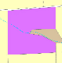
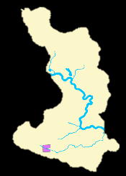
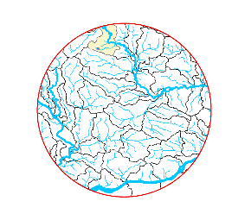
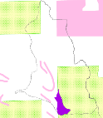
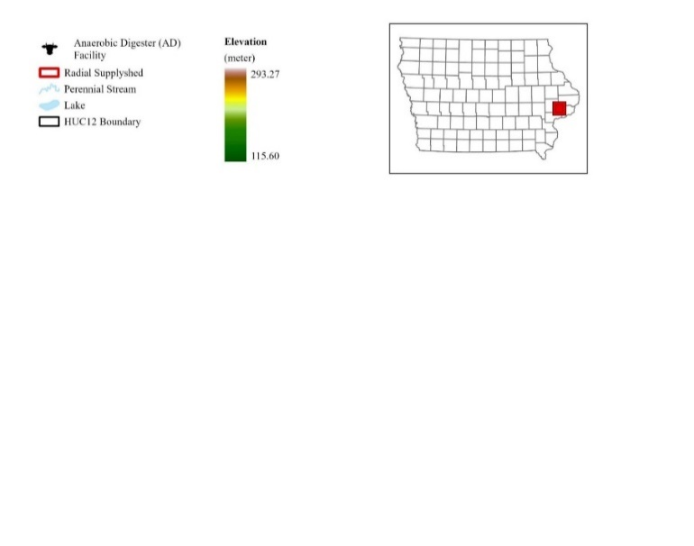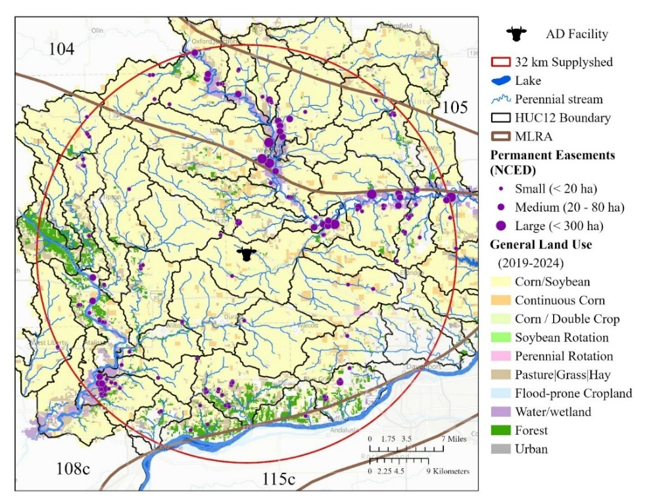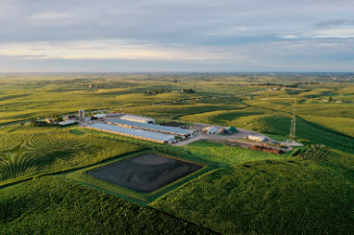
Field
HUC12
Supplyshed
Practice
Aggregate outcomes to public & private planning scales.
Figure 1. Location and landscape context of the case study anaerobic digestion (AD) facility and 32-km biomass supplyshed in east-central Iowa. The supplyshed encompasses 48 HUC12 watersheds and portions of four major land resource areas (MLRAs) within a predominantly corn–soybean agricultural landscape. Existing permanent conservation easements are distributed throughout the supplyshed, primarily near riparian corridors and floodplains.

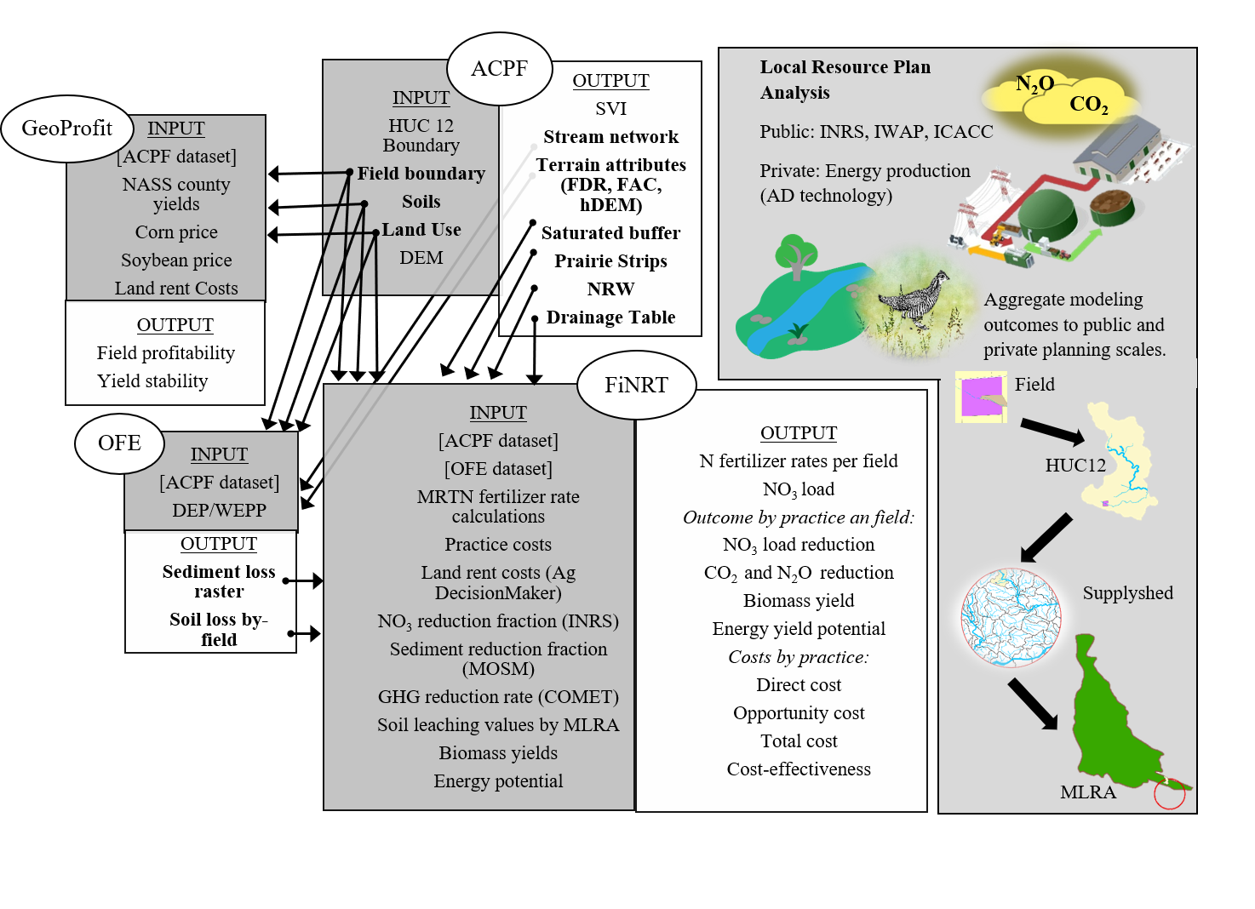
Figure. 2. Conceptual framework for systemic conservation planning (SCP) to achieve multi-functional land use planning that addresses both public and private objectives, including water quality, wildlife and bioeconomic.

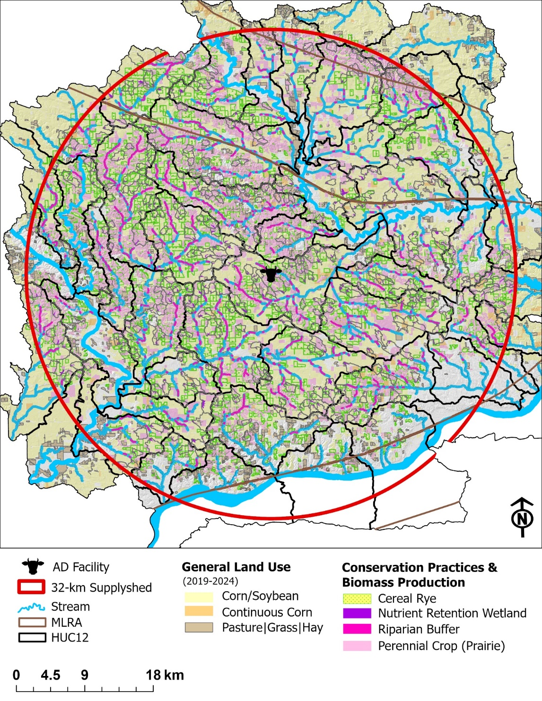
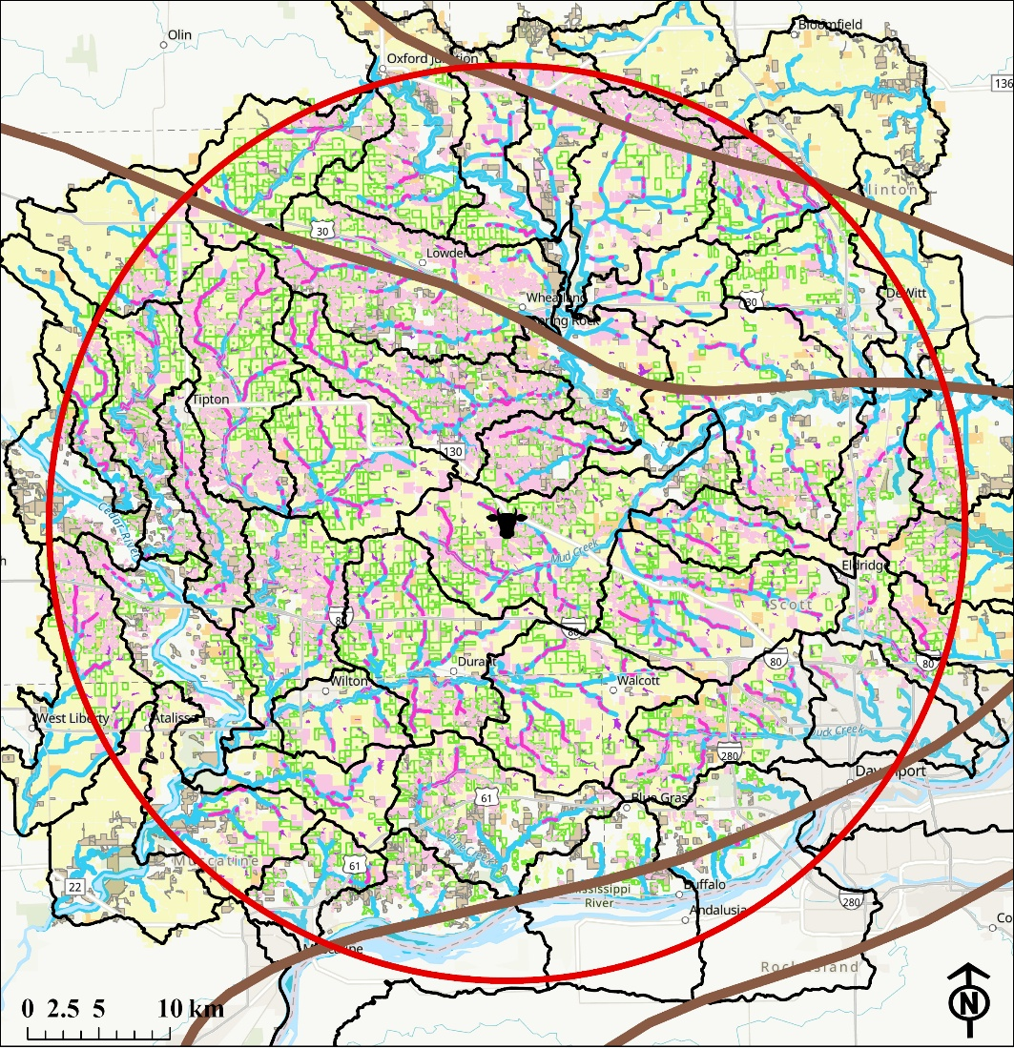

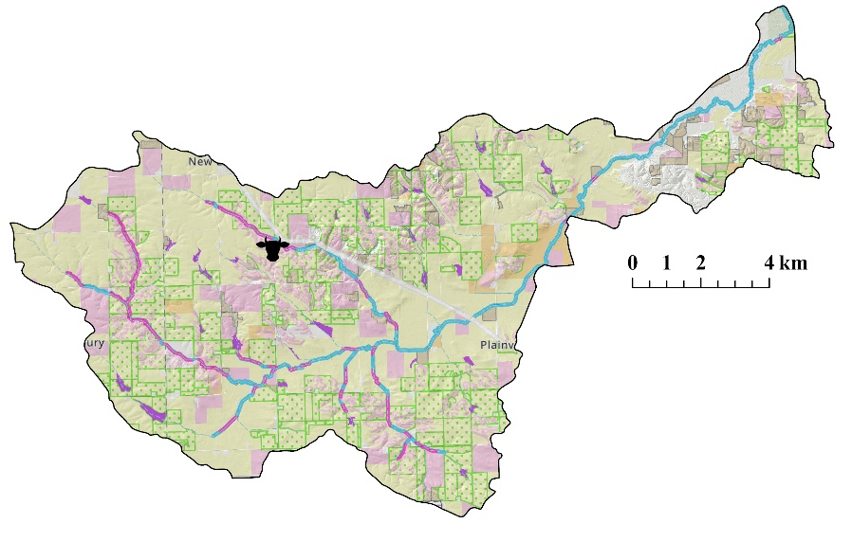

A.

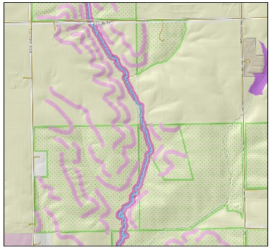
B.

Figure 3. Distribution of conservation practices (CP) and biomass production within 32 km of the study anerobic digestion (AD) facility. The CP locations are distributed throughout the region following INRS recommendations by major land resource area (MLRA) and IWAP recommendation to increase core habitat patches (whole field perennial crop) and linear habitat (riparian and saturated buffers, and prairie strips). The HUC12 watershed inset (A) illustrates spatial variation and hydrologic characteristics driving placement of vegetative practices, while the section-scale (B) illustrates how potential distribution of prairie and cereal rye biomass within conventionally cropped fields.

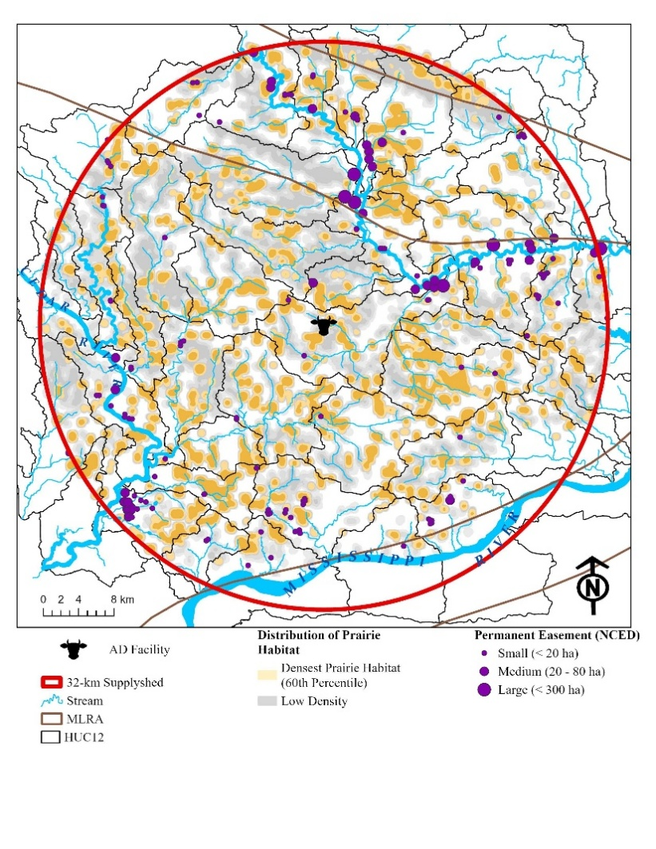
Figure 4. Wildlife habitat density mapping assuming 300 m travel distance between habitat. The purple color indicates where existing prairie habitat is located, while the orange color highlights modeled vegetative practice zones with the densest patches of prairie habitat overlap, while the grey areas represent areas with less habitat overlap.

